SELECT TOP

The **SELECT TOP** clause statement in SQL is used to specify the number of rows (or percentage of rows) to return from a query. It is primarily used to retrieve a limited number of records from a result set.

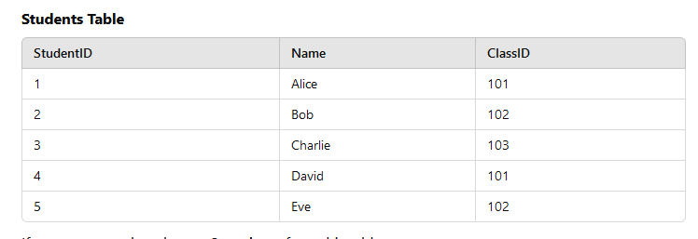

If you want to select the **top 3 students** from this table:

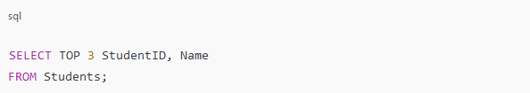

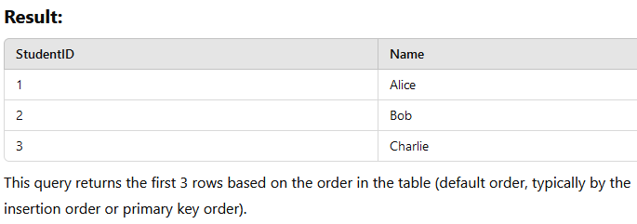

SELECT TOP – ORDER By

To get the top 3 students with the highest StudentID, use the ORDER BY clause:

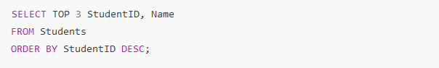

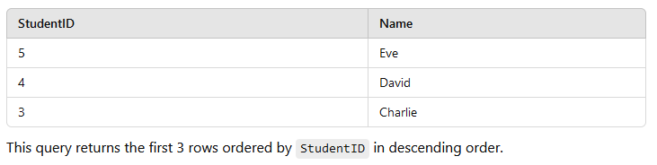

SELECT TOP – PERCENTAGE

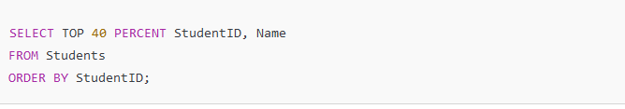

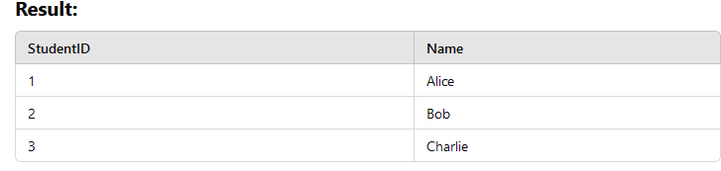

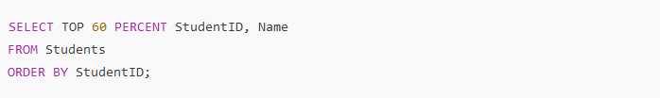

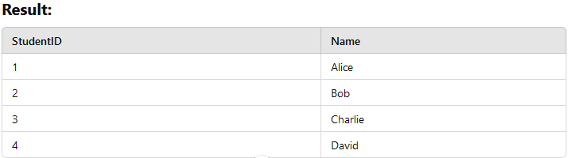

Now, 60% of 5 is 3 (rounded up), so the top 4 students are returned

**Rounding**: The percentage is typically rounded up in SQL Server, so it might return more rows than the exact percentage.

Aggregate function

**Aggregate functions** in SQL are special functions that perform calculations on multiple rows of data and return a single summarized value. These functions are commonly used in data analysis to compute totals, averages, counts, or other summaries from a dataset.

**Common Characteristics of Aggregate Functions:**

1. **Operate on Multiple Rows**: Aggregate functions process a set of values from a column.
2. **Return a Single Result**: They summarize the data into one value, such as a sum, count, or average.

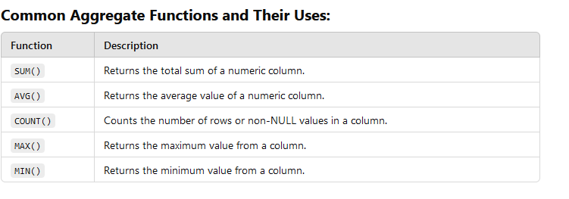

Sum()

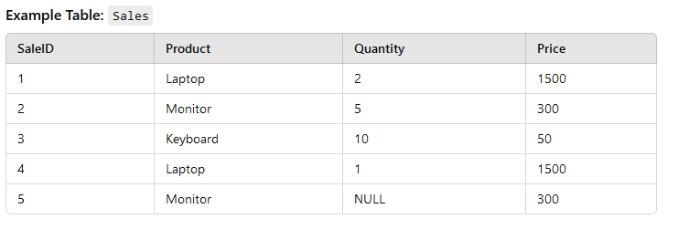

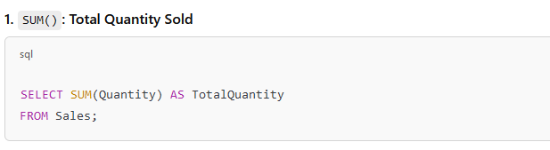

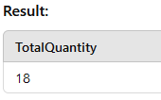

Avg()

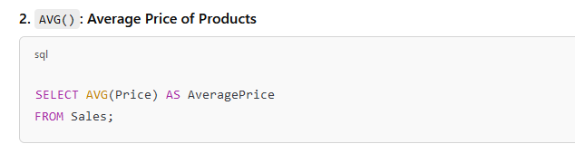

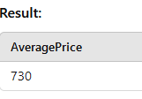

Count()

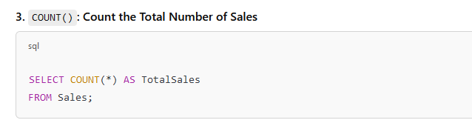

Use COUNT(*) to count all rows.

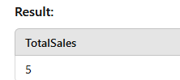

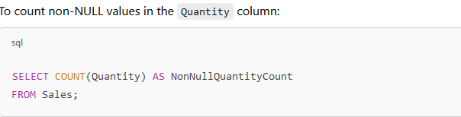

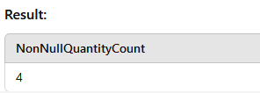

Max()

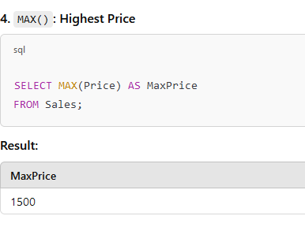

Min()

